CE312 | Report  TP1 - Modulo 16, 4-bits Counter
Date: | 03/11/2020
Students: | CELLARD Rémi - Damien Pierson-Maury
Subject: | Modulo 16 Counter on 4-bits

- Introduction
In this report, we’ll see how we can create a modulo 16 4-bits counter with VHDL code and simulate it in Vivado.

- Code of the modulo 16 4-Bits counter component
All the code for the component and the testbench are included at the end of the report, in annexes 1 and 2.
The chronogram of the testbench made by hand can be found in annex 3 and the chronogram resulting of the simulation in Vivado can be found in annex 4.

Annex 1 - Modulo 16 counter component code

library ieee;
use ieee.std_logic_1164.all;
use ieee.numeric_std.all;

entity compteur_16 is
port (
clk : in STD_LOGIC; -- clock signal
rst : in STD_LOGIC; -- reset signal
enable : in STD_LOGIC; -- enable signal
deb : out STD_LOGIC; -- bit overflow
out_count : out STD_LOGIC_VECTOR (3 downto 0) -- counter signal
);
end entity;

architecture archcompteur of compteur_16 is
signal debtmp : STD_LOGIC := '0';
signal outtmp : STD_LOGIC_VECTOR (3 downto 0) := (others=>'0');
-- two signal for made operations on it, because we can’t on out an in signal
begin
process(clk) -- active when event happen on signal clk
begin
if (clk'event and clk='1') then
if rst='1' then
debtmp <= '0';
outtmp <= (others=>'0');
elsif (enable='1') then -- no reset, counter enable
if (outtmp = "1111") then -- add bit overflow + reset out_count
outtmp <= (others=>'0');
debtmp <= not debtmp;
else
outtmp <= std_logic_vector(unsigned(outtmp)+ 1);
-- add 1 to unsigned
end if;
end if;
end if;
end process;

-- output assignment
deb <= debtmp;
out_count <= outtmp;
end architecture;
Annex 2 - Testbench code for the modulo 16 counter component

library IEEE;
use IEEE.STD_LOGIC_1164.ALL;
use IEEE.NUMERIC_STD.ALL;

entity tb_compteur_16 is
end tb_compteur_16;

architecture tb of tb_compteur_16 is
component compteur_16
port (
clk : in STD_LOGIC;
rst : in STD_LOGIC;
enable : in STD_LOGIC;
deb : out STD_LOGIC; -- bit overflow
out_count : out STD_LOGIC_VECTOR (3 downto 0)
);
end component;
signal clk_tb, rst_tb, enable_tb, deb_tb : STD_LOGIC;
signal out_count_tb : STD_LOGIC_VECTOR (3 downto 0);
begin
compteur: compteur_16 port map (clk=>clk_tb, rst=>rst_tb, enable=>enable_tb, deb=>deb_tb, out_count=>out_count_tb);

clock_10mhz_generation : process -- simulation of the clock signal
begin
clk_tb <= '0';
wait for 50 ns;
clk_tb <= '1';
wait for 50 ns;
end process;

procreset: process -- simulation of the reset signal
begin
rst_tb <= '1';
wait for 100 ns; -- we maintain the rst_tb signal on 100 ns
rst_tb <= '0';
wait for 1000 ns; -- we maintain the rst_tb signal on 100 ns
rst_tb <= '1';
wait for 100 ns; -- we maintain the rst_tb signal on 100 ns
rst_tb <= '0';
wait; -- we remove it permanently
end process;

procenable: process -- simulation of the enable signal
begin
enable_tb <= '1';
wait for 325 ns;
enable_tb <= '0';
wait for 75 ns;
enable_tb <= '1';
wait;
end process;
end architecture;

Annex 3 - Hand-processed chronogram of the testbench

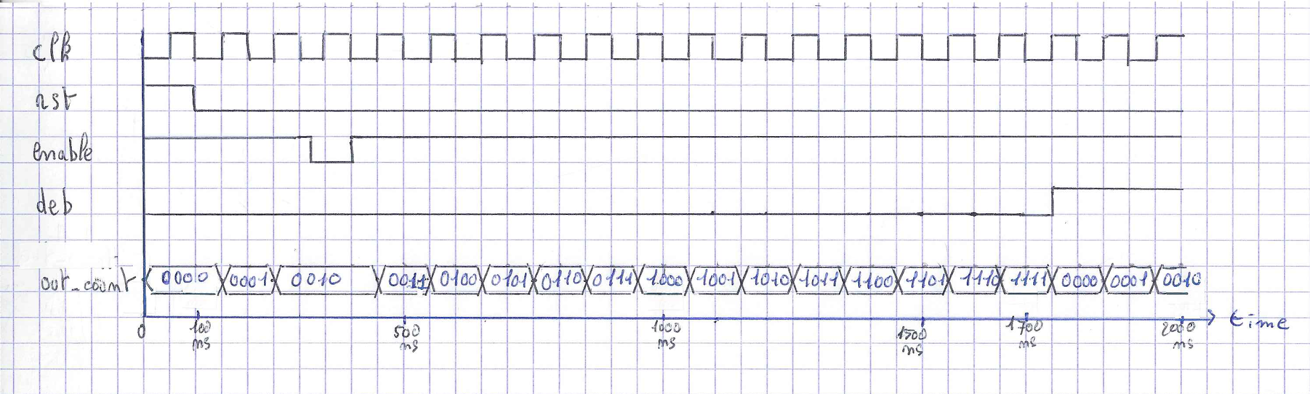

Annex 4 - Vivado-processed chronogram of the testbench, after simulation

